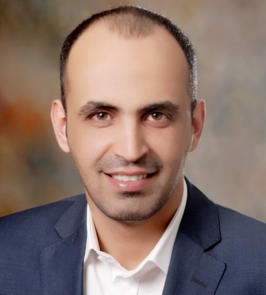
Faisal Al-Da'aja
User Experience Designer
Last update: January 07, 2019
www.faisal.me

BACKGROUND

I am a seasoned UX designer and UI engineer and have been designing/developing web-based platforms for many years. After all this time, I honed my craft at companies like Amazon, Souq.com, Yahoo!, Maktoob, N2V, MBC Group. And that to scale all platforms to operate at the best UX approaches (flows, wireframes, prototypes and visual design). and as well as applying concepts such as UX research, UX Strategy and Usability Testing.

CONTACT INFORMATION

Dubai, United Arab Emirates
Mobile number: 00971 - 585441020
Email: faisal.dajaa@gmail.com

CAREER OBJECTIVE

After 12 years of experience in digital design and based on qualitative & quantitative analyses of how people are using technology and what are the needs and goals of the audiences. I can say that I bring an engineering perspective and a creative problem-solving approach to build products and experiences people love and easy to use and how can make things better.
And to find a challenging position to meet my competencies, capabilities, skills, education and experience.

PROFESSIONAL EXPERIENCE
May 2018 – Present | Majid Al Futtaim - UX Manager
May 2017 – May 2018 | Amazon.com - UX Manager
August 2016 - May 2017 | Souq.com - UX Manager
June 2015- August 2016 | Souq.com - Senior UX/UI designer
October 2014 - June 2015 | Souq.com - Senior Front-End Software Engineer
February 2014 - October 2014 | MBC Group - Senior Front-End Developer
June 2013 - February 2014 | Mosqitech Company - Senior Front-End Developer
January 2012 - June 2013 | N2V Company - Entrepreneur In Residence
October 2009 – Jun 2012 | Yahoo! Maktoob Software Applications Development Engineering.
October 2008 - OCT 2009 | Maktoob.com - Web Designer and Front end Developer

EDUCATION
2008 | University of Jordan, Jordan  BA in Computer Information System .  With GPA Good.
2004 | Prince Faisal - Collage , Amman, Jordan  Diploma in Information Technology with average 82.9%
2001 | Al-Mqablain High School , Amman, Jordan  Science Major
EXPERIENCE

UX/UI Design Skills :
- UX Strategy
- Interaction design
- Customer journey
- Usability Testing
- Digital guidelines
- Visual design
- Heuristic evaluation
- UX research
- Accessibility
- Wire-framing and prototyping
- UX writing
- information architecture
- Connected the dots between business goals, user needs, innovation and good design.
- UI Design Patterns
- Web and App Design Trends
- Copywriting
- Contextual awareness
- Design and layout of newsletters and mailshots
- App designs and mobile screen sizes ( Android and iOS)
- Expert with how to use specialist software such as Sketch, Adobe Creative Suite, Axure, UXpin, invisionapp and Origami to enable you to design front-end experiences for potential users.
- Providing guidance to the team and assist them in removing any roadblocks

- Identify design tools, guidelines,new design techniques and processes that evolve existing approaches for the larger creative UX community

Developing the frontend of platforms with the following technologies:

- HTML4 - HTML5
- CSS, SASS, Less and Stylus
- MVC frameworks (Ember, AngularJS or Backbone)
- Search Engine Optimization (SEO)
- Smart Layout- Grids and Rows
- Mobile-first & Responsive web design
- Excellent experience with foundation zurb , Bootstrap and framework7
- BEM and OOCSS
- Web-app
- Semantic
- JavaScript, jQuery and Understanding of build tools like Grunt
- HTML and CSS Specifications (W3C / WHATWG)
- Mobile Web Performance
- Web high performance
- Bidirectional text
- Validation with W3C
- Compatibility with all the browsers
- Compatible with any device / Operating system
- Wordpress, Magento, osCommerce, Zen Cart, vBulletin and phpBB theme designs
- Version control systems (GIT)

Special Abilities:
Examine the quality and performance of websites and web portals
Designing and developing themes for various open-source CMS platforms.
Design of creative logos, brochures and trademarks.
Ongoing research and development on new design patterns and technologies

THE SAMPLES LIST OF PREVIOUS PROJECTS :

You can browse some samples through the following URLs:
http://www.faisal.me
https://www.behance.net/Faisal-Hanayfeh

LinkedIn profile :
https://jo.linkedin.com/in/faisaldajaa
Best regards
Faisal A. Al-Da'aja.
Mobile number: 00971 – 585441020
Email: faisal.dajaa@gmail.com

